Tokenization and Embedding in LLM Models

Introduction on LLM
- How typical LLM look like?
Qwen2ForCausalLM(
(model): Qwen2Model(
(embed_tokens): Embedding(151936, 1536)
(layers): ModuleList(
(0-27): 28 x Qwen2DecoderLayer(
(self_attn): Qwen2Attention(
(q_proj): Linear(in_features=1536, out_features=1536, bias=True)
(k_proj): Linear(in_features=1536, out_features=256, bias=True)
(v_proj): Linear(in_features=1536, out_features=256, bias=True)
(o_proj): Linear(in_features=1536, out_features=1536, bias=False)
)
(mlp): Qwen2MLP(
(gate_proj): Linear(in_features=1536, out_features=8960, bias=False)
(up_proj): Linear(in_features=1536, out_features=8960, bias=False)
(down_proj): Linear(in_features=8960, out_features=1536, bias=False)
(act_fn): SiLU()
)
(input_layernorm): Qwen2RMSNorm((1536,), eps=1e-06)
(post_attention_layernorm): Qwen2RMSNorm((1536,), eps=1e-06)
)
)
(norm): Qwen2RMSNorm((1536,), eps=1e-06)
(rotary_emb): Qwen2RotaryEmbedding()
)
(lm_head): Linear(in_features=1536, out_features=151936, bias=False)
)
- Tips
embedding layer and lm_head are shared (or tied together)
model.embed_tokens.weight
model.norm.weight
model.layers.0.self_attn.q_proj.weight
model.layers.0.self_attn.q_proj.bias
model.layers.0.self_attn.k_proj.weight
model.layers.0.self_attn.k_proj.bias
model.layers.0.self_attn.v_proj.weight
model.layers.0.self_attn.v_proj.bias
model.layers.0.self_attn.o_proj.weight
model.layers.0.mlp.gate_proj.weight
model.layers.0.mlp.up_proj.weight
model.layers.0.mlp.down_proj.weight
model.layers.0.input_layernorm.weight
model.layers.0.post_attention_layernorm.weight
... repeat 28 times

How tokenization and embedding working together

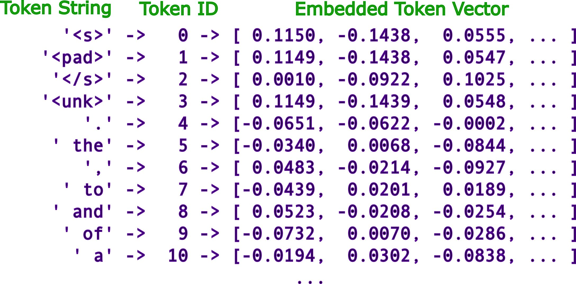
https://www.lesswrong.com/posts/pHPmMGEMYefk9jLeh/llm-basics-embedding-spaces-transformer-token-vectors-are

Tokenization
- Tokenization ensures text is broken into meaningful units that the model can understand.
- Tokenization: Think of it as breaking a book into individual pages or paragraphs for easier reading.
- Types of Tokenization:
  - Word-level: Splits text by spaces (e.g., "I love NLP" → ["I", "love", "NLP"])
  - Subword-level: Breaks words into common prefixes/suffixes for better handling of unseen words (e.g., "strawberry" → ["straw", "berry"])
  - Character-level: Splits every character as a token (e.g., "strawberry" → ["s", "t", "r", "a", "w", "b", "e", "r", "r", "y"])
- Examples
"Write a quick sort algorithm"
# Its token ids print out
4934 write
264 Ġa
3974 Ġquick
3378 Ġsort
12111 Ġalgorithm
13 .

Embedding Layer
- The embedding layer maps these tokens into dense vectors that capture semantic relationships.
- Embeddings: Imagine transforming each page into a numerical code that represents its meaning and context.
- The embedding layer converts tokens into dense vector representations that encode semantic meaning.
- Key Properties:
  - Dimensionality (e.g., 768-d for BERT)
  - Trainable weights that adjust during model training
- Examples
 | Token | Embedding Vector
1 | "apple" | [0.12, -0.45, 0.78, ...]
2 | "orange" | [0.15, -0.50, 0.81, ...]
- Some famous examples
  - Those vectors have meaning and can be manipulated like normal vectors
man - woman ≈ king - queen

Tokenization Challenges in Practice

Why LLMs Struggle with Certain Inputs
- Counting ‘r’ in “Strawbeery”
  - strawberry
  - This makes it hard to count “r”
  - In the word "strawberry," there is only one \'r\'.
  - But we can encode strawberry char by char, the model is smart to enough to answer this question
  - 82 s 83 t 81 r 64 a 86 w 65 b 65 b 68 e 81 r 88 y
There are 3 \'r\'s in the word "strawberry".
- In a sense, we made the model stupid

Why These Issues Occur
- Subword Tokenization Trade-off:
  - Optimized for efficiency
  - 1 token is roughly about 4 chars in English
  - Q, K, V cache grows on square on the length

https://colab.research.google.com/drive/104pxT42BGjE7pFZcsh1B3CWuUj9oLKpW#scrollTo=bqkL2QWDqLgR

What about real life example in tokenization?
Yes, here is model encode “ DEX”
422 ĠD
3257 EX
vs
10730 DEX

How is tokenizer stored in huggingface model card?
There are three files
* tokenizer.json
"0": 15,
"1": 16,
"2": 17,
"3": 18,
"4": 19,
"5": 20,
"6": 21,
"7": 22,
"8": 23,
"9": 24,

* tokenizer_config.json
"additional_special_tokens": [
"<|im_start|>",
"<|im_end|>",
"<|object_ref_start|>",
"<|object_ref_end|>",
"<|box_start|>",
"<|box_end|>",
"<|quad_start|>",
"<|quad_end|>",
"<|vision_start|>",
"<|vision_end|>",
"<|vision_pad|>",
"<|image_pad|>",
"<|video_pad|>"
],
* vocab.json

How Embedding Work
- Each token is mapped to a dense vector in an embedding matrix.
- Techniques include:
  - Pre-trained embeddings (e.g., Word2Vec, GloVe)
  - Learned embeddings within transformer models
- It is huge dictionary. It has basic meaning.

Potential issue
It is embedding for internet scale, will unlikely work for specific domain

One of particular challenge is domain specific concepts

Example
What are the top 3 meaning for DEX?
But you can fix it since it is a vector
DEX = 0.5 * Delivery + 0.5 Experience
What are the top 3 meanings for DEX?

Solutions and Best Practices
- Use character-level tokenization when precision is critical.
- Apply post-tokenization logic to reassemble text accurately for specific needs.
- Choose the appropriate tokenizer type based on task requirements.

Real-World Example
- Sample code illustrating tokenization and embedding using Hugging Face Transformers library.

Conclusion
- Recap of key points
- Emphasize the need to understand tokenization quirks for better model performance.

